**Component selection**

We have simulated the design and obtained some waveforms to decide on the components we will choose. The simulations are done under the real motor parameters and required voltage levels from us.As you can see from the figures diode peak voltage is nearly 200V and it will be enough to select diodes with Vrrm=250V. And, from the other figure, diode peak current is nearly 150 A. However, this case is worst scenario case. In other words it is at the starting moments of the motor which has very current at starting. we will implement a controller for it to reduce that current. However even if we don’t implement a controller we may overcome this problem with another ways therefore, current value of the diodes are determined later. And our mosfet should bear nearly 150 A values. And, since we are operating at 500 Hz frequency for the mosfet these also should be considered.

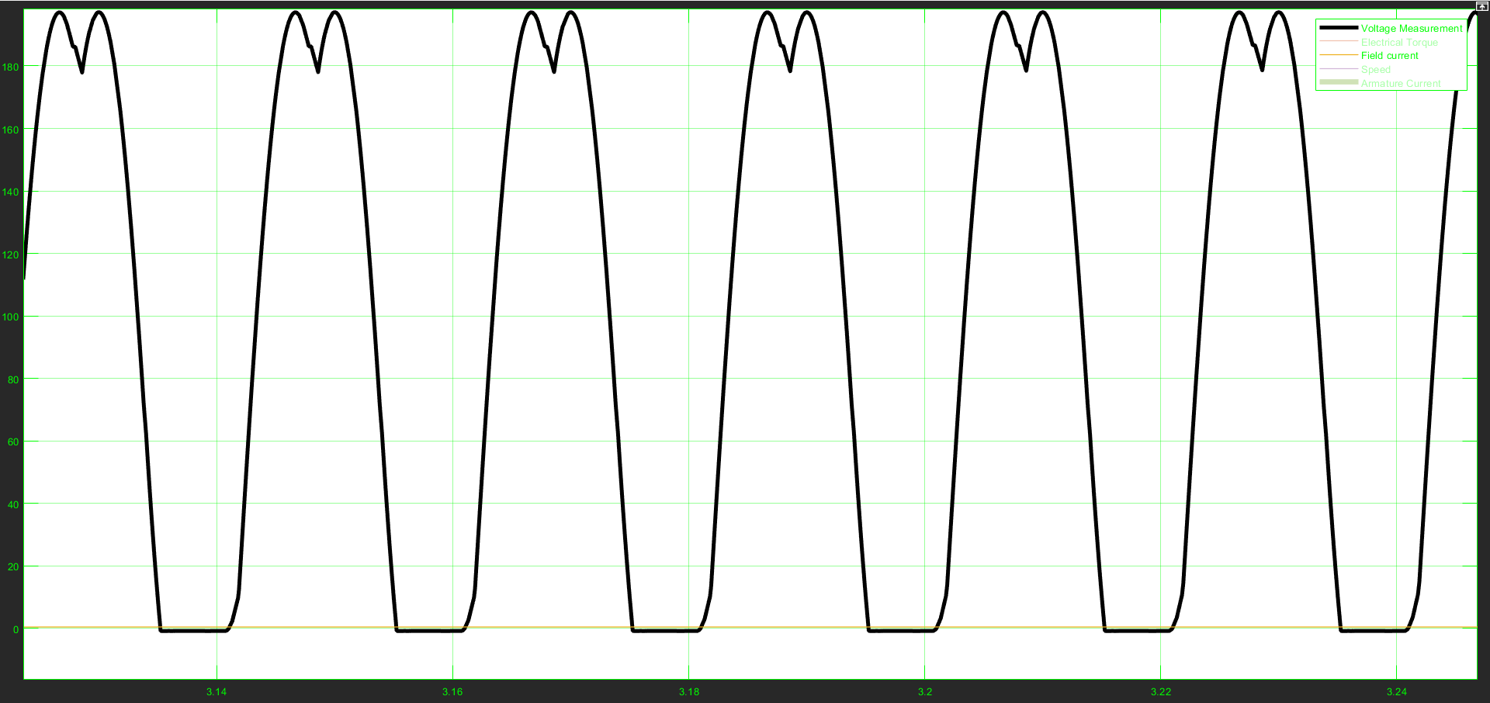

Figure: simulation of diode Reverse repetitive peak voltage.

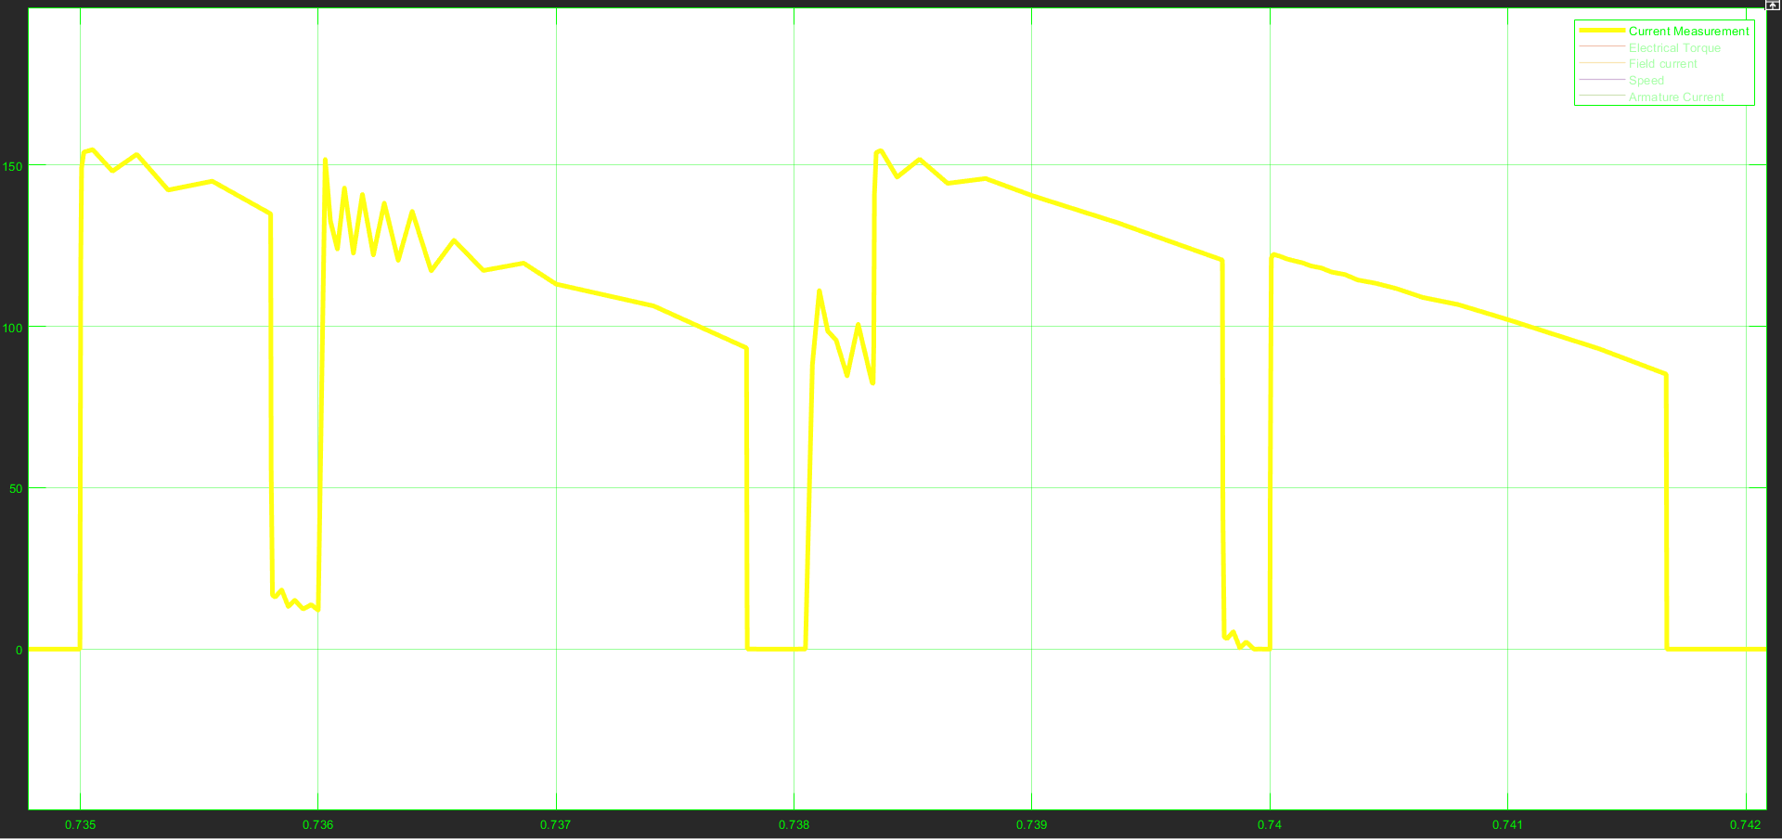

Figure: simulation of diode currents.

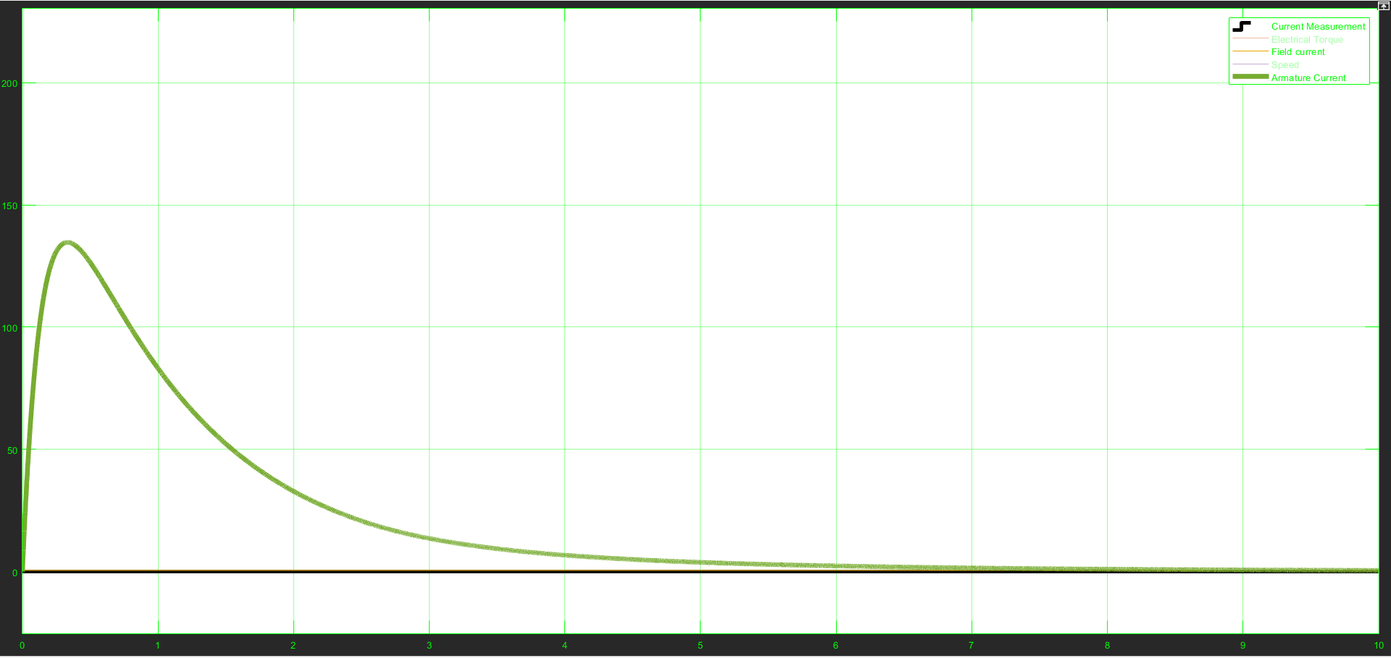

Figure: armature current half of which pass on mosfet.